Austin Parker

CTIS 345

Professor Rob Whitnell

15 October, 2022

**Individual Assignment 3**

**PE 6-4**

1. A & B.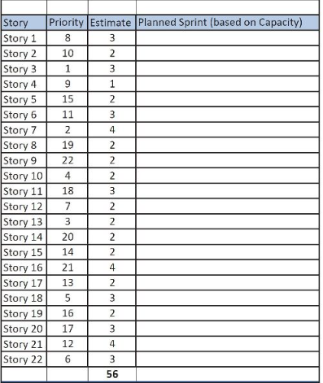

Sprint 1

Sprint 1

Sprint 1

Sprint 1

Sprint 2

Sprint 1

Sprint 1

Sprint 2

Sprint 2

Sprint 1

Sprint 2

Sprint 1

Sprint 1

Sprint 2

Sprint 2

Sprint 2

Sprint 2

Sprint 1

Sprint 2

Sprint 2

Sprint 2

Sprint 1

C. At most, this would take two sprints, as outlined above in parts A/B combined.

D. I think that since we’re able to go with the assumption that the estimates are accurate, Hybrid release planning is unnecessary for this and Agile sprint-by-sprint is more than acceptable.

**PE 6-7**

A/B.

| **Story ID** | **Estimate (x) total within sprint** | **Dependencies** | **Priority/Rank** | **Sprint** |
| --- | --- | --- | --- | --- |
| PC1 | 4 |  | MH/1 | 1 |
| PC3 | 4 |  | MH/1 | 1 |
| PC4 | 4 |  | MH/1 | 1 |
| PC5 | 4 | PC4 | MH/1 | 1 |
| IE1 | 2 |  | MH/1 | 1 |
| IE2 | 3 |  | MH/1 | 1 |
| IE4.1 | 3 (24) |  | MH/1 | 1 |
| EP1.1 | 3 |  | MH/1 | 2 |
| EP2 | 2 |  | MH/1 | 2 |
| ME2.1 | 3 |  | MH/1 | 2 |
| ME4 | 3 |  | MH/1 | 2 |
| PC2 | 3 |  | SH/2 | 2 |
| PC6 | 4 |  | SH/2 | 2 |
| IE3 | 4 |  | SH/2 | 2 |
| IE5 | 3(25) |  | SH/2 | 2 |
| IE6 | 4 |  | SH/2 | 3 |
| ME1 | 4 |  | SH/2 | 3 |
| ME3 | 4 |  | SH/2 | 3 |
| ME5.1 | 3 |  | SH/2 | 3 |
| ME6 | 2 |  | SH/2 | 3 |
| ME7 | 3 |  | SH/2 | 3 |
| ME8 | 4(24) |  | NH/3 | 3 |
| IE4.2 | 5 | IE4.1 | NH/3 | 4 |
| EP1.2 | 4 | EP1.1 | NH/3 | 4 |
| EP3 | 4 |  | NH/3 | 4 |
| ME2.2 | 4 | ME2.1 | NH/3 | 4 |
| ME5.2 | 4(21) | ME5.1 | NH/3 | 4 |

C. This will take approximately 4 sprints to finish.

D. Approximately 1.5 sprints to finish all MH priorities.

E. As it stands currently, the MH priorities equate to 11 within the second sprint. Adding an additional 15 days would put the sprint over by 1 day, meaning that the MH priorities would carry over into the next sprint, or sprint 3. This would add an additional sprint on the back end.

**PE 6.8**

| **MWRE Agile Release Plan (Flight Plan)** | | | | |
| --- | --- | --- | --- | --- |
| **Sprint 1** | | **Sprint 2** | **Sprint 3** | **Sprint 4** |
|  |  |  |  |  |
|  |  |  |  |  |
|  |  |  |  |  |
|  |  |  |  |  |